**Colorado Association of Education And Rehabilitation**

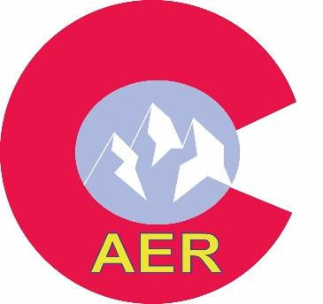**Building Bridges Together**

**CAER Offers Financial Assistance to Colorado Clients, Students, Families, and Professionals Through Mini-Grants.**

**Mini-Grant funds are available to defray the costs of:**

* Conference Attendance
* Student Activities
* Programming Needs
* Professional development projects
* Other ideas are welcome

**Mini-grant Rules:**

1. Applicant must be a current CAER member or be sponsored by an CAER member.

2. The maximum amount of funds available will vary; the allotted amount per grant will not exceed $300.

3. Recipients are only eligible to receive a mini-grant once every **two** years.

4. Recipients need to provide CAER with a presentation of how the mini-grant money was used **within 30 days** of use of funds. This will be shared with members at the annual CAER banquet.

5. Board members applying for a mini-grant will recuse themselves from voting in that mini-grant cycle.

6. Mini-grant applications are accepted throughout the year, but due by January 1st. The grants are awarded once per year in January.

7. If funds are not used for the intended purpose, the mini-grant funds need to be returned to the CAER board by the recipient.

Funding decisions are made by your elected CAER Board of Directors and must be approved by a 2/3rds of voting members.

**Mini-Grant Application Form**

Name:

Address:

Phone:

Work:

Email:

AER membership #:

Recommending AER Member name:

1. For what purpose are you applying for a mini-grant? (Attach page, as necessary

1. How much financial assistance are you requesting? (Max $300)
2. List/itemize your expenses:
3. Have you contacted other sources for assistance? If so, please list the name(s) of the organizations, the amount requested and the amount pledged.
4. If awarded a Mini Grant, you are required to submit a presentation (in some form) to the CAER board within 30 days of using the funds.

If funds are not used for the intended purpose or presentation isn’t submitted in a timely fashion, I agree to refund the funds to CAER

Signature of Applicant

**Email completed application form to: caerboard@gmail.com**