# 

# **AER Division 19 Newsletter, Winter 2024**

**You’re off to great places! Today is your day! Your mountain is waiting. So…get on your way!** – Dr. Seuss

Hello, Division 19!

Welcome to the Winter edition of the Physical Activity and Recreation Division’s newsletter. I hope that you have been able to spend some time with friends and family enjoying the holiday season.

We have much to look forward to this winter and spring! There are several conferences (in-person and online) offering continuing education opportunities for professionals, and there are also sports camps this winter for children and young adults. We’re also excited to spotlight the work of the Northwest Association for Blind Athletes (NWABA), which is offering a new internship this summer.

As always, we always welcome suggestions for improving the division. Please email us with your interest in becoming more involved, thoughts, comments, and questions at [aerbviphysicalactivity@gmail.com](mailto:aerbviphysicalactivity@gmail.com).

Cheers,

Katie Ericson, M.Ed., TVI/COMS

Secretary

**Division Business**

Due to the holidays, the board met briefly via email this December to discuss the newsletter. As a reminder, board meeting minutes can be found on the [division website](https://www.aerbvi.org/division_physicalactivity).

**Questions & Suggestions**

As a member of D-19, you are welcome to reach out to the board with concerns, questions, and suggestions: Past Chair, [Adam Pennell](mailto:adam.pennell@pepperdine.edu); Chair, [Erin Weaver](mailto:eweaver@aph.org); Chair-Elect, [M. Ally Keene](mailto:mkeen002@odu.edu); Treasurer, [Lauren Lieberman](mailto:Lauren%20Lieberman%20%3cllieberm@brockport.edu%3e); Secretary, [Katie Ericson](mailto:katherine.e.ericson@gmail.com).

To help grow D-19 membership, please remember to promote AER and D-19 during your presentations and trainings.

**Online Seminars**

Division 19 would like to host your APE-related online seminar/webinar. Please send your presentation suggestion/submission to [Erin](mailto:eweaver@aph.org).

**Conferences and Meetings**

**State/Regional AER Meetings**

**Dates Vary**

Many state and regional AER chapters are holding meetings in the coming months. This is a great opportunity to meet others in your area and share your knowledge. See [AER’s website](https://www.aerbvi.org/) for dates and more information.

**South Pacific Educators in Vision Impairment (SPEVI) Conference**

**January 13-15, 2025, Brisbane, Australia AND Online**

The SPEVI Conference highlights the work of teachers and researchers from Australia, New Zealand, and Pacific islands. This year’s conference includes a strand dedicated to sports and physical activity, featuring presentations from Vision Australia, Blind Sports Western Australia, and the University of Queensland. More information can be found on the [conference website](https://www.speviconference.net/).

**SHAPE America National Convention & Expo**

**April 1-5, 2025, Baltimore, MD**

Join your peers at the [2025 SHAPE America National Convention & Expo](https://convention.shapeamerica.org/) — the nation’s leading convention for health and physical education professionals. Participate in exclusive sessions and workshops based on the newly revised National Physical Education Standards and National Health Education Standards.

**International Symposium on Physical Activity and Visual Impairment or Deafblindness**

**June 16-20, 2025, Tralee, Kerry, Ireland**

The 3rd International Symposium on Physical Activity and Visual Impairment or Deafblindness will be held in conjunction with the [International Symposium on Adapted Physical Activity](https://www.isapa2025.com/). The call for proposals has been extended to February 1, 2025; please consider sharing your research and/or practical knowledge with your international colleagues.

**Winter Sports and Camps**

* [NWABA Camp Spark (Session 6 - Sandy, OR), Feb. 14-17, 2025](https://nwaba.org/programs/camp-spark/schedule/)
* [Camp Abilities Delaware Winter Camp, Feb. 15-17, 2025](https://www.campabilitiesdelaware.org/winter-camp.html)
* [Winter Camp Abilities, Feb. 19-23, 2025](https://www.cabvi.org/services/adaptive-sports-recreation/camp-abilities-cabvi/)
* [Camp Abilities Brockport Winter Mini Camp, Feb. 21, 2025](https://www.campabilities.org/)
* Camp Abilities Kean University Winter Mini Camp, Feb. 22, 2025 (email [Dr. Alex Stribing](mailto:stribina@kean.edu) for more information or to register)
* [NWABA Camp Spark (Session 4 - Rhododendron, OR), Feb. 28-Mar. 2, 2025](https://nwaba.org/programs/camp-spark/schedule/)
* [USABA Winter Sports](https://www.usaba.org/winter-sports/)
* [BRAVO (Blue Ridge Adventures ~ Vision Optional)](https://www.blueridgebravo.org/school-year-programming)

**Other Sports and Camps**

* [Camp Exsighting Adventures](https://www.campexsightingadventures.com/home), July 6-11, 2025; registration for Counselors in Training, Leaders in Training, and campers opens January 1, 2025
* [The Great Lakes Adapted Sports Association (GLASA) Great Lakes Games](https://glasa.org/great-lakes-games/) will be held June 12-16, 2025 in the greater Chicago, IL area. More information coming soon.

**Other Opportunities**

**NWABA Adapted Sports Specialist**

We are currently hiring a [Adapted Sport Program Specialist](https://nwaba.org/wp-content/uploads/2024/12/PS_PDX_Program_Specialist_JD_2024_12_12_FINAL.pdf) to lead and represent our growth area in the Greater Portland and Vancouver region.

This role is ideal for someone passionate about empowering individuals who are blind or visually impaired through adaptive sports and recreation. The Program Specialist will deliver life-changing programs, build meaningful partnerships, and play a key role in driving NWABA's mission forward.

**Key Highlights of the Position:**

* Serve as the growth area lead for Portland & Vancouver, focusing on strategic initiatives.
* Deliver adaptive sports and recreation programs across 20+ activities, including tandem biking, kayaking, hiking, skiing, and more.
* Build relationships with athletes, volunteers, and community partners.
* Enjoy competitive compensation, benefits, and a collaborative team environment.

This is an **in-office position based in Vancouver, WA**, with a relocation stipend available. A full job description and application details are attached.

**To Apply:**Interested candidates should email their résumé, cover letter (addressing the two questions below), and three professional references to recruiting@nwaba.org.

1. Why are you interested in working with the Northwest Association for Blind Athletes?
2. What is your experience in planning and leading adaptive sports or recreation programs? Provide examples, including specific achievements and metrics where possible.

**Applications missing any components will not be considered.**

**NWABA Internship**

**Northwest Association for Blind Athletes (NWABA)** is excited to announce their new **Sports Outreach Internship Program** for summer 2025, designed to provide hands-on experience in adaptive sports and program event planning for students passionate about making a difference for individuals who are blind or visually impaired at NWABA. This 9-week internship will run from early June through early August, offering students the opportunity to work closely with our athletes, staff, and volunteers. We expect this to be highly competitive as we only have two openings for 2025.

**Program Highlights:**

* **Duration**: 9 weeks (40 hours/week)
* **Compensation**: $20/hour, with a $500 travel reimbursement and a $1000 lodging stipend
* **Capstone Activity**: Interns will plan and execute an adaptive sports event as a final project.

**Interested Candidates**:  
We’re currently gathering contact information from interested students before the application opens in January. If you know students who would be a great fit, please forward them this link to our [Interest Form](https://forms.office.com/r/sAC6T45uwQ). We’ll reach out to all interested students directly with application instructions.

**Focus on…**

**Northwest Association for Blind Athletes**

**Empowering Individuals with Visual Impairments: Explore NWABA’s Programs and Services**

At the Northwest Association for Blind Athletes (NWABA), we are dedicated to transforming the lives of individuals who are blind and visually impaired through sports, physical activity, and recreation. Since 2007, our mission has been to empower people of all ages and abilities to reach their greatest potential by providing accessible, equitable programs and services.

**What We Offer**

NWABA provides a wide range of adaptive sports programs tailored to meet the unique needs of individuals with visual impairments. From kayaking and goalball to Camp Spark and tandem biking, we offer opportunities for participants to build confidence, enhance physical and mental health, and connect with a supportive community.

Our **Sports Adaptations Program** is a cornerstone of our offerings. This program provides specialized tools, techniques, and equipment to make sports and physical activities accessible for individuals with visual impairments. Whether you’re a beginner or an experienced athlete, we ensure you have the resources and support to succeed. You can access our video resource library, adapted equipment lending, and our virtual consultations at no-cost.

NWABA also offers **Virtual Programs**, extending our reach to individuals across the nation. These programs include adaptive fitness classes, wellness sessions, and sports-specific training, all delivered through an accessible online platform. No matter where you live, you can connect with NWABA and enjoy inclusive opportunities to stay active and engaged.

**How to Get Involved**

To learn more about NWABA’s programs, services, and events, visit our website at [www.nwaba.org](http://www.nwaba.org/). You can also email us at **programsteam@nwaba.org** to inquire about upcoming activities, register for programs, or explore how we can support your journey toward independence and health through sports and recreation.

**Educational Aids for Sports**

**Tactile Graphics for Sports**

APH offers free templates for good tactile designs to help facilitate communication between those involved with the design and execution of tactile graphics. The [Tactile Graphic Image Library](https://imagelibrary.aph.org/portals/aphb/#login)’s categories are divided into core and expanded core curriculum areas. Download Options are Original (PDF), Thumbnail, and Preview (opens in browser to view, JPG). If you don't see what you are looking for, please send an email at [tgfeedback@aph.org](mailto:tgfeedback@aph.org).

**Publications**

**Books**

The 2nd edition of Physical Education & Sport for Individuals with Visual Impairment or Deafblindness: Foundations of Instruction will be published this winter through APH Press!

**Articles & Chapters**

Ball, L., & Lieberman, L. J. (2024). Blind and Visually Impaired Sport (V. Girginov & L. Misener, Eds.). Routledge Resources Online: Sports Studies. <https://doi.org/10.4324/9780367766924-RESS115-1>

Blavt, O., & Zahura, F. (2024). Physical education in the realization of educational inclusion of students with disabilities as a result of war. *Theory and Practice of Teaching.* <https://doi.org/10.5281/zenodo.14567641>

Dispo, G. A. N., Magat, S. M. C., Arambulo, A. L., & De Guzman, F. (2025). Lived experiences of students with visual impairment in virtual physical education learning during the COVID-19 pandemic. British Journal of Visual Impairment, 0(0). https://doi.org/10.1177/02646196241305288

Iannacchino, C., Lieberman, L. J., Beach, P., & Perreault, M. (2024). A preliminary investigation of physical education teachers’ perceptions of pre-teaching students with visual impairments. *The New Review, 2*(1), 27-21. <https://doi.org/10.56733/TNR.22.014>

Keene, M. A., Haegele, J., & Zhu, X. (2024). The association between sports camp participation and perceived competence and independence among visually impaired youth. *Journal of Youth Development, 19*(4), 49-57.

Lieberman, L. J., Childs, R., Pennell, A., & Brian, A. (2024). The physical self-advocacy assessment inventory for adolescents with and without disabilities: A Delphi study. *International Journal of Kinesiology in Higher Education,* 1-13. https://doi.org/10.1080/24711616.2023.2298384

Nowland, L. A., Zhu, X., & Haegele, J. A. (2024). Self-Efficacy to Teach Students with Disabilities Across Instructional Placements for Physical Education Scale: Development and Validation. *Measurement in Physical Education and Exercise Science*, 1–14. <https://doi.org/10.1080/1091367X.2024.2439307>

Stribing, A., Gilbert, E. N., Lieberman, L. J., & Brian, A. (2024). Do parental beliefs and support predict the motor competence of youth with visual impairments? *Journal of Motor Learning and Development, 12*(2), 269-286.

<https://doi.org/10.1123/jmld.2023-0033>

**Miscellanea**

**Camp Abilities Iceland**

The inaugural Camp Abilities Iceland was held in Reykjavik this October, and 18 athletes from around Iceland had the opportunity to participate in horseback riding, swimming, track and field, cardio drumming, blind soccer, showdown, goalball, and judo. Board Treasurer Dr. Lauren Lieberman, four of her students from SUNY Brockport, and researchers/coaches from the University of South Carolina, Rochester Institute of Technology, and the University of Nebraska all traveled to Iceland to take part. Below, Ben Lytle (an orientation and mobility specialist from the University of Nebraska) shares more about the Camp Abilities Iceland experience and adapted sports in Iceland.

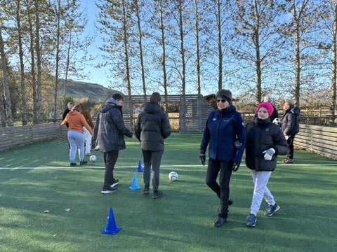

(Photo courtesy of Dr. Lauren Lieberman)

Setting up Camp Abilities in Iceland was a collaborative effort, based at a children’s summer camp in Reykjadalur, Iceland. In the two days before the athletes arrived, volunteers, researchers, and instructors prepared the venue for accessibility and readiness. Equipment for activities such as blind soccer, aerobic drumming, and indoor track and field events was organized with tactile and auditory adaptations where needed. Swimming and judo areas were set up with safety in mind, rock climbing featured adaptive harnesses and guides, and horseback riding incorporated gentle, well-trained horses. Every detail was designed to ensure an inclusive and empowering experience.

When the 17 athletes arrived, they were welcomed into an environment full of energy and opportunity. Each activity highlighted their abilities and built confidence. Blind soccer improved teamwork and spatial awareness, aerobic drumming encouraged rhythm and coordination, and swimming and judo helped develop strength and resilience. Indoor track and field events, including the high jump, pushed physical boundaries, while rock climbing tested problem-solving and determination. Horseback riding, set against Iceland’s landscapes, and sounds provided a therapeutic and memorable experience. Athletes bonded, explored their potential, and celebrated their achievements, making Camp Abilities Iceland a meaningful success.

The culture of Icelandic sports reflects a deep connection to community, resilience, and inclusivity, extending across all levels of ability. Despite being a small nation with a challenging climate, Iceland has built a thriving sports culture that emphasizes accessibility and broad participation. Local sports clubs, or *íþróttafélög*, serve as the backbone of this culture, offering opportunities for people of all ages and abilities to engage in athletic activities. The country is also renowned for its focus on youth development, with structured programs that prioritize skill-building, enjoyment, and long-term growth over early specialization.

A strong spirit of resilience underpins Icelandic sports, shaped by the nation’s rugged environment. Iceland actively promotes adaptive sports, ensuring that individuals with disabilities can fully participate and compete. Organizations such as Íþróttasamband fatlaðra (the Icelandic Sports Association for the Disabled) lead the way in fostering opportunities and support for adaptive athletes.

Gender equality is another hallmark of Icelandic sports culture. Investments in women’s sports and the celebration of female athletes highlight the nation’s commitment to equity. The inclusiveness extends to outdoor and nature-based activities, where adaptive options allow everyone to enjoy Iceland’s dramatic landscapes through hiking, skiing, or horseback riding. Ultimately, Iceland’s sports culture stands as a testament to the power of community, resilience, and inclusivity in fostering a thriving athletic spirit.

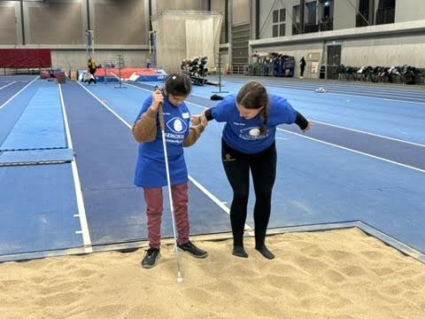

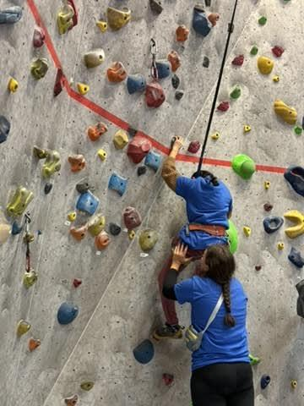

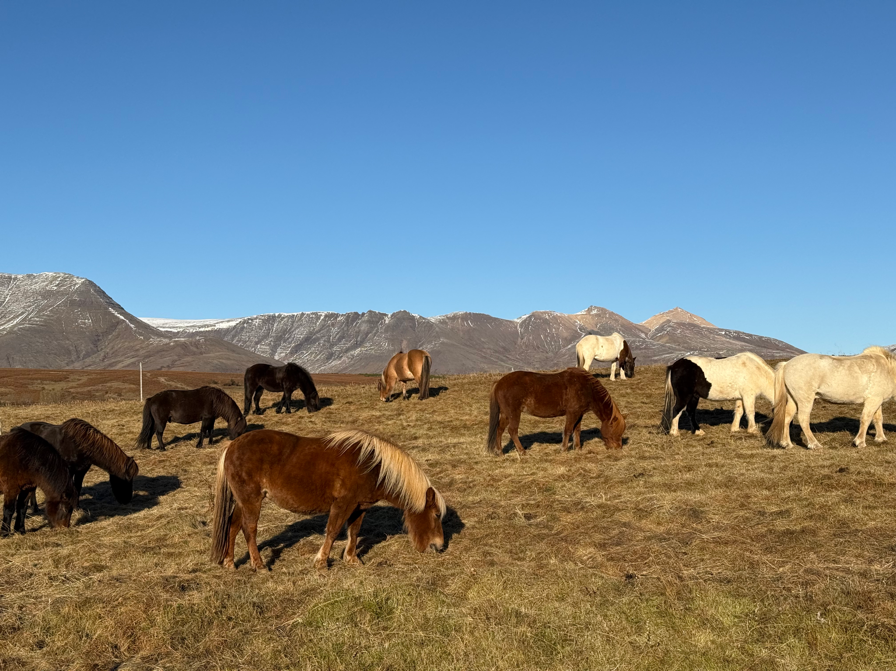

**Accepting Spring 2025 AER D-19 Newsletter Submissions**

[Send your news](mailto:tpierce@aph.org), stories, events, bragging rights, recruitment efforts, and suggestions. The deadline is **February 21**.